PROGRAMMING IN C

1. **Algorithm and Programming Development**

C programming language works as an interface between the programmer and the computer.

## PDLC: Program Development Life Cycle

PDLC consists of seven steps:

* + Problem Definition/Analysis
  + Program Designing
  + Algorithm Development and Flowcharting
  + Program Coding
  + Debugging and Compilation
  + Program Testing
  + 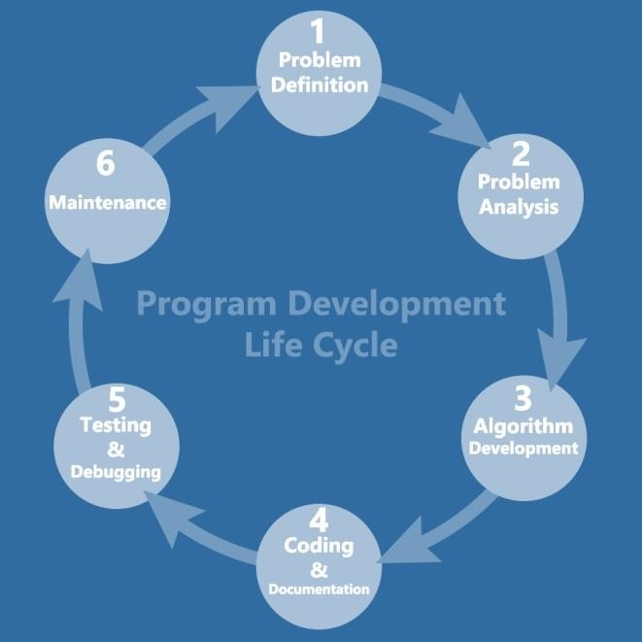Implementation and Documentation

#### Problem Definition/Analysis

Before writing a program, it is must to have proper understanding of the problem.

#### Program Designing

It consists of five steps:

* + Design Input
  + Design Output
  + Code Design
  + Form Design
  + Module Design

#### Algorithm Development and Flowcharting

Algorithm:

It is a step-by-step solution of the problem written in simple language.

Algorithm Example 1: Write an algorithm to add two nos.

Step1: start Step2: Read a, b

Step3: sum = a + b Step4: write sum Step5: stop Flowchart:

It is the graphical representation of an algorithm.

**Several standard graphics are applied in a flowchart:**

* Terminal Box - Start / End

Terminal Box Figure

* Input / Output

Input / Output Figure

* Process / Instruction

Process Figure

* Decision

Decision Figure

* Connector / Arrow

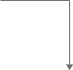

The graphics above represent different part of a flowchart. The process in a flowchart can be expressed through boxes and arrows with different sizes and colors. In a flowchart, we can easily highlight a certain element and the relationships between each part.

### How to Use Flowcharts to Represent Algorithms

Now that we have the definitions of algorithm and flowchart, how do we use a flowchart to represent an algorithm?

Algorithms are mainly used for mathematical and computer programs, whilst flowcharts can be used to describe all sorts of processes: business, educational, personal, and of course algorithms. So, flowcharts are often used as a program planning tool to visually organize the step-by-step process of a program. Here are some examples:

### Print numbers from 1 to 20: Algorithm:

Step 1: Initialize X as 0,

Step 2: Increment X

by 1,

Step 3: Print X,

Step 4: If X is less than 20 then go back to step 2.

### Flowchart: Flowchart Algorithm Example 2: Convert Temperature from Fahrenheit (℉) to

**Celsius (℃) Algorithm:**

Step 1: Read temperature in Fahrenheit, Step 2: Calculate temperature with formula C=5/9*(F-32), Step 3: Print C

Flowchart:

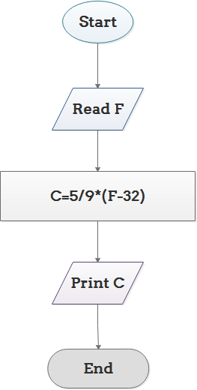

### Conclusion

From the above we can come to a conclusion that a flowchart is pictorial representation of an algorithm, an algorithm can be expressed and analyzed through a flowchart.

An algorithm shows you every step of reaching the final solution, while a flowchart shows you how to carry out the process by connecting each step. An

algorithm uses mainly words to

describe the steps while a [flowchart uses the symbols,](https://www.edrawsoft.com/flowchart-symbols.php) shapes and arrows to make the process more logical.

1. Program Coding:

When the algorithm is developed and tested; it needs implementation using that language. This is known as program coding.

1. Debugging and Compilation:

Once the program is ready, it must be checked for errors. An error is also known as bug.

Error/Bug: there are three types of errors or bugs:

* + Syntax error
  + Semantics error/Logical error
  + Execution error a).Syntax Error:

A grammatical error is known as syntax error. Example of syntax error:

Correct: printf(“Welcome to the world of C”); Incorrect: printf(“Welcome to the world of C”);

The incorrect statement is not terminated by a semicolon b).Semantics error/Logical error:

There is requirement to write a program to add two numbers; but the programmer did subtraction.

c=a+b; (correct) c=a-b; (incorrect) c).Execution Error:

execution error is also known as runtime error. Example:

1. divide by zero
2. infinite loop

Debugging:

Isolation of errors and their removal is known as debugging. Compilation:

Compilation is the process of converting source program into an object program. Source program:

The program written in C (middle level language). Object program:

The program written in machine language (0’s & 1’s). Shortcut for compilation in C is: Alt+F9

6).Program Testing:

The program is tested before implementation.

For testing a program, some sample data is calculated manually. Then, same data is given as input to the program.

The output of program is compared to the manual output.

If the result is ok, then there are no logical errors present in the program; but, if the output is incorrect, it means that some logical errors are present in the program. To locate these errors, one has to go back third step i.e. check algorithms and flowcharts and locate problems. Correct problems, recode the program, recompile program and test program again. These steps are repeated time and again; until, output during testing becomes correct.

7).Implementation and documentation: There are three main steps:

1. Installation of software
2. Maintenance of software
3. Documentation of software

#### Characteristics of good program:

1. Efficient
2. Reliable
3. Flexible
4. Extensible
5. Portable
6. Integrity
7. Robustness
8. Clarity

#### Program Approaches:

* + Top-down approach
  + Modular approach or structured programming
  + Bottom-up approach

C language follows top-down approach.

## C program structure:

* + C is a middle level language as it has features of both Low-Level Language & High-Level Language.

BRIEF HISTORY OF C:

C was developed in 1972 by Ken Thompson and Dennis Ritchie at Bell Laboratories, USA. PREDESSOR OF C:

* + **B/BCPL**(Basic Combined Programming Language) SUCESSOR OF C:

#### C++ Working With C:

The most commonly used C compilers are: Borland C (BC)

Turbo C (TC)

Turbo C is more followed than Borland C.

|  |  |  |
| --- | --- | --- |
| Source Program (written in C)  Alt+F9 (compilation)  **program’s** | Compiled Program (object program)  Ctrl+F9 (run/execution)  **program.obj** | Executable Program Alt+F5  (to view the exe file)  **program.exe** |

Compiler Linker

Compiler:

The compiler converts source program to object program. Linker:

The linker converts object program to executable program.

## The C character set:

|  |  |  |
| --- | --- | --- |
| Type of character | Description | characters |
| Lowercase alphabets | a to z | A,b,…z |
| Uppercase alphabets | A to Z | A,B…Z |
| Digits | 0 to 9 | 0,1,…9 |
| Special characters | ` to ? | `,~,…? |
| White spaces | Blank spaces to new line | Blank spaces, carriage  return,…new line |

Special characters:(32)

|  |  |
| --- | --- |
| **`** | **Backtick** |
| **~** | **Tilde** |
| **@** | **At the rate of** |
| **!** | **exclamation mark** |
| **$** | **Dollar** |
| **#** | **Hash** |
| **^** | **Caret** |
| **\*** | **Asterisk** |
| **%** | **percentage** |
| **&** | **ampersand** |
| **(** | **Left parenthesis** |
| **)** | **right parenthesis** |
| **[** | **left bracket** |
| **]** | **Right bracket** |
| **{** | **Left brace** |
| **}** | **Right brace** |
| **<** | **Less than** |
| **>** | **Greater than** |
| **+** | **Add** |
| **=** | **Equal to** |
| **_** | **Underscore** |
| **-** | **Minus** |
| **|** | **Vertical bar** |
| **/** | **Slash** |
| **\** | **Backslash** |
| **;** | **Semicolon** |
| **:** | **Colon** |
| **‘** | **apostrophe** |
| **“** | **Quotation mark** |
| **,** | **Comma** |
| **.** | **Period** |
| **?** | **Question mark** |

White spaces:

|  |  |
| --- | --- |
| Blank spaces | Single spacebar |
| Carriage return | Enter |

|  |  |
| --- | --- |
| Horizontal tab | Eight horizontal spaces |
| Vertical tab/Form feed | Eight vertical spaces |
| New line | Next line |

Escape sequences:

|  |  |
| --- | --- |
| Escape Sequences | |
| Escape Sequences | Character |
| \f | Form feed |
| \n | Newline |
| \r | Return |
| \t | Horizontal tab |
| \v | Vertical tab |
| \\ | Backslash |
| \' | Single quotation mark |
| \" | Double quotation mark |

|  |  |
| --- | --- |
| \? | Question mark |
| \0 | Null character |

|  |  |  |  |
| --- | --- | --- | --- |
| **Data Type** | **Format Specifier** | **Minimal Range** | **Typical Bit Size** |
| unsigned char | %c | 0 to 255 | 8 |

#### Data types in C:

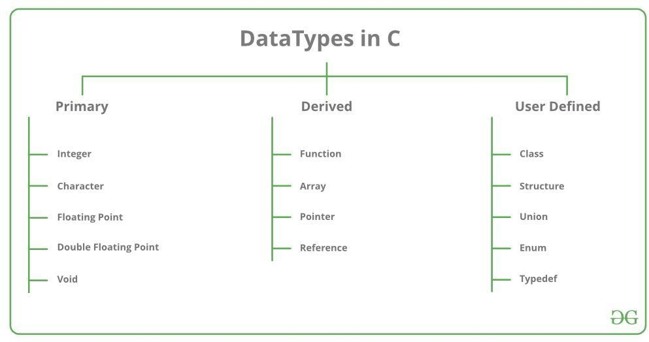

**Primary data types in C:**

|  |  |
| --- | --- |
| **Data type** | **Format specifier** |
| integer | “%d” |
| character | “c” |
| float | “%f” |
| double | “%lf” |
| void | void |

**Storage classes in C:**

|  |  |  |  |
| --- | --- | --- | --- |
| char | %c | -127 to 127 | 8 |
| signed char | %c | -127 to 127 | 8 |
| int | %d, %i | -32,767 to 32,767 | 16 or 32 |
| unsigned int | %u | 0 to 65,535 | 16 or 32 |
| signed int | %d, %i | Same as int | Same as int 16 or 32 |
| short int | %hd | -32,767 to 32,767 | 16 |
| unsigned short int | %hu | 0 to 65,535 | 16 |
| signed short int | %hd | Same as short int | 16 |
| long int | %ld, %li | -2,147,483,647 to 2,147,483,647 | 32 |
| long int | %lld, %lli | -(263 – 1) to 263 – 1 (It will be added by the C99 standard) | 64 |
| signed long int | %ld, %li | Same as long int | 32 |
| unsigned long int | %lu | 0 to 4,294,967,295 | 32 |
| float | %f | 1E-37 to 1E+37 along with six digits of the precisions here | 32 |
| double | %lf | 1E-37 to 1E+37 along with six digits of the precisions here | 64 |
| long double | %Lf | 1E-37 to 1E+37 along with six digits of the precisions here | 80 |

|  |  |  |  |  |  |
| --- | --- | --- | --- | --- | --- |
| **Class** | **Name of Class** | **Place of Storage** | **Scope** | **Default Value** | **Lifetime** |
| auto | Automatic | RAM | Local | Garbage Value | Within a function |
| extern | External | RAM | Global | Zero | Till the main program ends. One can declare it anywhere in a program. |

**Derived types**

|  |  |  |  |  |  |
| --- | --- | --- | --- | --- | --- |
| static | Static | RAM | Local | Zero | Till the main program ends. It retains the available value between various function calls. |
| register | Register | Register | Local | Garbage Value | Within the function |

1. Pointer types,
2. Array types,
3. Structure types,
4. Union types and
5. Function types.

### C Operators:

An operator is a symbol that tells the compiler to perform specific mathematical or logical functions. C language is rich in built-in operators and provides the following types of operators:

* + Arithmetic Operators
  + Relational Operators
  + Logical Operators
  + Bitwise Operators
  + Assignment Operators
  + Special Operators

# Arithmetic Operators

The following table shows all the arithmetic operators supported by the C language. Assume variable **A** holds 10 and variable **B** holds 20 then −

[Show Examples](https://www.tutorialspoint.com/cprogramming/c_arithmetic_operators.htm)

|  |  |  |
| --- | --- | --- |
| **Operator** | **Description** | **Example** |
| + | Adds two operands. | A + B = 30 |
| − | Subtracts second operand from the first. | A − B = -10 |
| * | Multiplies both operands. | A * B = 200 |

# Relational Operators

|  |  |  |
| --- | --- | --- |
| / | Divides numerator by de- numerator. | B / A = 2 |
| % | Modulus Operator and remainder of after an integer division. | B % A = 0 |
| ++ | Increment operator increases the integer value by one. | A++ = 11 |
| -- | Decrement operator decreases the integer value by one. | A-- = 9 |

The following table shows all the relational operators supported by C. Assume variable **A** holds 10 and variable **B** holds 20 then −

[Show Examples](https://www.tutorialspoint.com/cprogramming/c_relational_operators.htm)

|  |  |
| --- | --- |
| **Operator** | **Description** |
| == | Checks if the values of two operands are equal or not. If yes, then the condition becomes true. |
| != | Checks if the values of two operands are equal or not. If the values are not equal, then the condition becomes true. |
| > | Checks if the value of left operand is greater than the value of right operand. If yes, then the condition becomes true. |
| < | Checks if the value of left operand is less than the value of right operand. If yes, then the condition becomes true. |
| >= | Checks if the value of left operand is greater than or equal to the value of right operand. If yes, then the condition becomes true. |
| <= | Checks if the value of left operand is less than or equal to the value of right operand. If yes, then the condition becomes true. |

# Logical Operators

Following table shows all the logical operators supported by C language. Assume variable **A** holds 1 and variable **B** holds 0, then −

[Show Examples](https://www.tutorialspoint.com/cprogramming/c_logical_operators.htm)

|  |  |  |
| --- | --- | --- |
| **Operator** | **Description** | **Example** |
| && | Called Logical AND operator. If both the operands are non-zero, then the condition  becomes true. | (A && B) is false. |
| || | Called Logical OR Operator. If any of the two operands is non-zero, then the condition  becomes true. | (A || B) is true. |
| ! | Called Logical NOT Operator. It is used to reverse the logical state of its operand.  If a condition is true, then Logical NOT operator will make it false. | !(A && B) is true. |

# Bitwise Operators

Bitwise operator works on bits and perform bit-by-bit operation. The truth tables for &, |, and

^ is as follows −

|  |  |  |  |
| --- | --- | --- | --- |
| **p** | **q** | **p & q** | **p | q** |
| 0 | 0 | 0 | 0 |
| 0 | 1 | 0 | 1 |
| 1 | 1 | 1 | 1 |
| 1 | 0 | 0 | 1 |

Assume A = 60 and B = 13 in binary format, they will be as follows − A = 0011 1100

B = 0000 1101

A&B = 0000 1100

A|B = 0011 1101

A^B = 0011 0001

~A = 1100 0011

The following table lists the bitwise operators supported by C. Assume variable 'A' holds 60 and variable 'B' holds 13, then −

[Show Examples](https://www.tutorialspoint.com/cprogramming/c_bitwise_operators.htm)

|  |  |  |
| --- | --- | --- |
| **Operator** | **Description** | **Example** |
| & | Binary AND Operator copies a bit to the result if it exists in both operands. | (A & B) = 12, i.e., 0000 1100 |
| | | Binary OR Operator copies a bit if it exists in either operand. | (A | B) = 61, i.e., 0011 1101 |
| ^ | Binary EXOR Operator copies the bit if it is set in one operand but not both. | (A ^ B) = 49, i.e., 0011 0001 |
| ~ | Binary One's Complement Operator is unary and has the effect of 'flipping' bits. | (~A ) = ~(60), i.e.,. ~00111100  11000011 |
| << | Binary Left Shift Operator. The left operands value is moved left by the number of  bits specified by the right operand. | A << 2 = 240 i.e., 1111 0000 |
| >> | Binary Right Shift Operator. The left operands value is moved right by the number  of bits specified by the right operand. | A >> 2 = 15 i.e., 0000 1111 |

# Assignment Operators

The following table lists the assignment operators supported by the C language − [Show Examples](https://www.tutorialspoint.com/cprogramming/c_assignment_operators.htm)

|  |  |  |
| --- | --- | --- |
| **Operator** | **Description** | **Example** |
| = | Simple assignment operator. Assigns values from right side operands to  left side operand | C = A + B will assign the value of A + B to C |
| += | Add AND assignment operator. It adds the right operand to the left operand  and assign the result to the left operand. | C += A is equivalent to C = C + A |
| -= | Subtract AND assignment operator. It subtracts the right operand from the  left operand and assigns the result to the left operand. | C -= A is equivalent to C = C - A |
| *= | Multiply AND assignment operator. It multiplies the right operand with the  left operand and assigns the result to the left operand. | C *= A is equivalent to C = C * A |
| /= | Divide AND assignment operator. It divides the left operand with the  right operand and assigns the result to the left operand. | C /= A is equivalent to C = C / A |
| %= | Modulus AND assignment operator. It takes modulus using two operands  and assigns the result to the left operand. | C %= A is equivalent to C = C % A |
| <<= | Left shift AND assignment operator. | C <<= 2 is same as C = C << 2 |
| >>= | Right shift AND assignment operator. | C >>= 2 is same as C = C >> 2 |
| &= | Bitwise AND assignment operator. | C &= 2 is same as C = C & 2 |
| ^= | Bitwise exclusive OR and assignment operator. | C ^= 2 is same as C = C ^ 2 |

|  |  |  |
| --- | --- | --- |
| |= | Bitwise inclusive OR and assignment operator. | C |= 2 is same as C = C | 2 |

Increment & Decrement operators:

There are two types of Increment operators in C:

a).prefix increment b=++a;

In prefix increment, the current value of a will be incremented first by 1. Then the new value will be assigned to b for the expression in which it is used in the same line.

b).postfix increment b=a++;

The postfix increment operator allows the usage of the current value of a variable in an expression and then increments its value by 1 in next line.

c).prefix decrement:

b=--a;

In prefix decrement, the current value of a will be decremented first by 1. Then the new value will be assigned to b for the expression in which it is used in the same line.

d).postfix decrement:

b=a--;

The postfix decrement operator allows the usage of the current value of a variable in an expression and then decrements its value by 1 in next line.

**Syntax of conditional operator in C**

variable = condition? statement 1: statement 2;

If the condition is true(1), then statement 1 will be executed & its value will be assigned to the variable.

If the condition is false(0), then statement 2 will be executed & its value will be assigned to the variable.

#### Special Operators in C:

There are 4 special operators in C: a).Comma operator

b).& operator c).* operator

d).sizeof operator

#### a).Comma operator

it is used to combine many operators together example:

for(a=0,b=0;a<=10;a++)

#### & operator

it is also known as address operator. It is used to print address of any memory location.

#### * operator

it is also known as indirection operator. Example:

int *ptr; float *ptr1;

#### d).sizeof operator

it is used to measure size of memory occupied by any variable. C Keywords:

There are 32 keywords in C.

These are reserved words and cannot be used for variable or identifier name.

|  |  |  |  |  |  |  |  |
| --- | --- | --- | --- | --- | --- | --- | --- |
|  |  |  |  | **C Key** | **words** |  |  |
|  | auto |  | double |  | int |  | struct |
|  |  |  |  |  |  |  |  |
|  | break |  | else |  | long |  | switch |
|  |  |  |  |  |  |  |  |
|  | case |  | enum |  | register |  | typedef |
|  |  |  |  |  |  |  |  |
|  | char |  | extern |  | return |  | union |
|  |  |  |  |  |  |  |  |
|  | continue |  | for |  | signed |  | void |
|  |  |  |  |  |  |  |  |
|  | do |  | if |  | static |  | while |
|  |  |  |  |  |  |  |  |
|  | default |  | goto |  | sizeof |  | volatile |
|  |  |  |  |  |  |  |  |
|  | const |  | float |  | short |  | unsigned |

**Control structures in C:**

Control structures are of four types:

* Sequence control statements
* Decision control statements/ Conditional control statements
* Case control statements
* Loop control statements

**Sequence control statements:**

These statements are executed in same order in which they appear in the program. Such a program is known as monolithic program. No control structure is needed in such programs.

### Decision control statements/ Conditional control statements:

* **If statement**

### If-else statement

* **Nested if statement a). If statement:**

it is used when a set of statements are to be executed depending upon a specified condition.

### Syntax of if statement:

If (condition)

{

Set of statements to be executed when if condition is true.

}

**Example:** #include<stdio.h> void main( )

{

int a,b;

printf(“enter a & b”); scanf(“%d %d”,&a, &b); if (a>b)

{

printf(“a is greater”); printf(“b is smaller”);

}

}

### b).If-else statement:

this statement is used when there are two possible results of a question. Syntax of if-else statement:

if (condition)

{

Statements;

}

else

{

Statements;

}

Example: #include<stdio.h> void main( )

{

int a,b;

printf(“enter a & b”); scanf(“%d %d”,&a, &b); if (a>b)

{

printf(“a is greater”);

}

else

printf(“b is greater”);

}

}

### c).Syntax of nested if:

if(condition1)

{statements}

else{if (condition2)

{statements} else

}

}

Switch statement:

Syntax of switch statement:

Switch(expression)

{

Case constant 1:

Statements;

Case constant 2:

Statements;

Default :

Statements;

}

#### Break statement:

It is used to transfer control out of the current loop.

#### Syntax of break statement:

break;

#### exit function:

**syntax:**

exit( );

it transfers the control out of the program. It stops the execution of the program.

#### Loop structures in C:

* For loop
* While loop
* Do while loop a).for loop:

syntax of for loop:

for(initialization part; conditional part; increment/decrement part)

{

statements;

}

b).while loop:

#### syntax of while loop:

while(condition)

{

Statements;

}

If condition is true, statements will be executed; otherwise statements will not be executed. c).do-while loop:

**syntax of do while loop:**

do

{

Statements;

}while(condition);

In do while loop condition is checked at the end of the loop.

So, do while loop will be executed at least once; even though the condition is false.

**POINTERS IN C**

**Pointer:**

A pointer is a variable that stores the address of another variable. It is also known as indirection operator.

### Pointer Declaration: Syntax:

Data type *ptr1, *ptr2,……*ptrn;

### Example:

int *a;

### Indirection operator:

* is known as indirection operator.

## Functions in C:

Function:

A function is a subroutine that performs a particular task. Types of functions:

a). user defined functions b). built-in functions

#### user defined functions:

these are the functions that are defined by the user.

#### built-in functions:

these functions are pre-defined in C header files.

#### For example:

The function clrscr( ) is defined in header file conio.h

#### Examples of some header files:

pow( ), printf( ), scanf( ), sin( ), cos( )

#### Argument:

It is used to pass the information between functions and main( ). Types of Arguments:

1. formal arguments or dummy arguments
2. actual arguments #include<stdio.h> #include<conio.h>

/* program to add two numbers using function */ void main( )

{

int a, b; clrscr();

printf(“enter a and b”); scanf(“%d %d”,&a, &b);

add (a, b); /* call to add function. a and b are actual arguments */

}

void add(int a1, int b1) /*a1 and b1 are formal or dummy arguments */

{

int c; c=a+b;

printf(“%d”,c);

}

#### Parameter passing in functions:

* Call by value
* Call by reference

#### Call by value:

In call by value, the value of actual parameter is passed to formal parameter.

/* program to swap two numbers using call by value */ #include<stdio.h>

#include<conio.h> main()

{

int a, b; clrscr();

printf(“enter a and b”); scanf(“%d %d”, &a,&b); swap(a,b);

printf(“value in main after swapping”); printf(“%d %d”, a, b);

}

void swap (int a1, int b1)

{

Int c; c=a1; a1=b1; b1=c;

printf(“value in function after swapping”); printf(“%d %d”, a1, b1);

}

#### Output:

Enter a and b 5 6

value in function after swapping 6 5 value in main after swapping 5 6

#### Call by reference:

In call by reference, the address of actual parameters is passed to formal parameters.

/* program to swap two numbers using call by value */ #include<stdio.h>

#include<conio.h> main()

{

int a, b; clrscr();

printf(“enter a and b”); scanf(“%d %d”, &a,&b); swap(&a,&b);

printf(“value in main after swapping”); printf(“%d %d”, a, b);

}

void swap (int *a1, int *b1)

{

Int c; c=*a1;

*a1=*b1;

*b1=c;

printf(“value in function after swapping”); printf(“%d %d”, *a1, *b1);

}

#### Output:

Enter a and b 5 6

value in function after swapping 6 5

value in main after swapping 6 5

#### Recursion:

It is the ability of a function to call itself.

#### ARRAY

**Array:**

An array is a finite, ordered set of homogeneous elements. Types of array:

* One dimensional array
* Two dimensional array

#### One dimensional array:

**Syntax:**

<Type of elements> array name [no. of elements in row]; For example:

int num [10];

2bytes 2bytes

|  |  |  |  |  |  |  |  |  |  |
| --- | --- | --- | --- | --- | --- | --- | --- | --- | --- |
|  |  |  |  |  |  |  |  |  |  |

a[0] a[1] a[2] a[3] a[4] a[5] a[6] a[7] a[8] a[9]

#### two dimensional array:

**Syntax:**

<Type of elements> array name [no. of elements in row][no. of elements in column]; For example:

int num [5][3];

|  |  |  |  |  |
| --- | --- | --- | --- | --- |
| num[0][0] | num[0][1] | num[0][2] | num[0][3] | num[0][4] |
| num[1][0] | num[1][1] | num[1][2] | num[1][3] | num[1][4] |
| num[2][0] | num[2][1] | num[2][2] | num[2][3] | num[2][4] |

#### Array of characters:

char name[5]={‘a’, ‘b’, ‘c’, ‘d’, ‘e’};

1 byte 1byte 1byte 1byte 1byte name[0] name[1] name[2] name[3] name[4]

|  |  |  |  |  |
| --- | --- | --- | --- | --- |
| a | b | c | d | e |

**STRINGS**

Collection of characters is known as string.

a string is enclosed by “ ”

STRING LITERALS AND VARIABLES:

Alphabets: (a-z)

(A-Z)

numeric digits: (0-9)

special characters:32

String Related Functions:

(a) strlen()

(b) strcpy()

(c) strcmp()

**(a) strlen():**

this function is used to measure length of string

Example:

void main()

{

int i;

char a[10];

printf(“enter string”);

scanf(“%s”,a);

i=strlen(a);

printf(“%d”,i);

getch();

}

**(b) strcpy():**

this function is used to copy one string 2 on string 1

Example:

void main()

{

char str1[10];

char str2[10];

printf(“enter string1”);

scanf(“%s”,str1);

printf(“enter string2”);

scanf(“%s”,str2);

printf(“\nbefore strcpy”);

printf(“%s”,str1);

strcpy(str1,str2);

printf(“\n after strcpy the string is\n”);

printf(“%s”,str1);

}

Output:

enter string1

hello

enter string2

how are you

**before strcpy:**

hello

**after strcpy:**

how are you

**(c) strcmp():**

It is a string compare function.

It is used to compare two strings.

If strings are equal, 0 is returned as output.

If strings are not equal, then, difference of first non-matching character in ASCII-

Form is displayed as output.

Example:

void main()

{

char a[10], b[10];

int i;

printf(“enter string a and string b”);

scanf(“%s%s”, a,b);

i=strcmp(a,b);

if (i==0)

printf(“strings are equal”);

else

printf(“strings are not equal”);

getch();

}

All strings end with ‘\0’ or NULL.

**STRUCTURES**

Structure is defined as heterogeneous collection of variables grouped under a

single logical entity.

Declaration of structure:

Syntax:

struct struct-type

{

type member1;

type member2;

.

.

.

};

The declaration of structure is also known as ‘blueprint of structure’.

No memory is allocated to structure by declaration.

On defining the variable, memory will be allocated to structure.

All members of structure occupy continuous memory.

Example:

struct student

{

char name[10];

int age;

int marks;

};

struct student s;

memory allocation:

s.name=10 bytes

s.age=2 bytes

s.marks=2 bytes

total memory=14 bytes

**UNIONS**

Unions are similar to structures. Like structures, unions is also collection of

dissimilar data types.

Union contain number of members like structure; but, only one is active at a time.

Difference of structure and union:

1. For declaration of structure, keyword struct is used.
2. In a structure, all data members are active at a time
3. A structure is most commonly used data structure in c.
4. For declaration of structure, keyword union is used.
5. In a union, only one data memory is active at a time.
6. A union is not commonly used.

Syntax for declaration of union:

union union name

{

Datatype member1;

Datatype member2;

.

.

.

};

Example:

#include<stdio.h>

#include<conio.h>

Union abc

{

float a;

int b;

};

Void main()

{

abc=0;

0.a=5.5;

0.b=6.5;

Printf(“%d %d”, 0.a, 0.b);

}

**FILE HANDLING IN C:**

A file is a collection of logically related records.

FILE OPERATIONS:

Naming a file/ Creating a file

Opening a file

Reading the data from a file

Writing data to a file

Editing/ modifying data in a file

Closing a file

**Naming a file/ Creating a file**

File name is a string of characters.

Some valid filenames:

Student.dat

Salary.txt

**Opening a file:**

C allows automatic creation of file when we open it in writing mode.

Formatt:

FILE *fp;

fp=fopen(“Filename”,”mode”);

FILE OPENING MODES:

‘r’: read only mode i.e.

It opens file only for reading data in it.

‘w’:write only mode

It opens file only for writing data to it.

‘a’:append mode

The file is opened to add or append data to it.